Lineshape data
Saved in pkl files as pandas dataframes. Each folder has 3 pkl files, ending in data, data_corr, and fits. Data contains raw counts (no corrections). Data_corr contains memory+intensity corrected data. Fits contains all the fitted parameters from gaussian/Lorentzian fits tried, basically the same information as in the Th_record_db.
Example of corrected data dataframe:
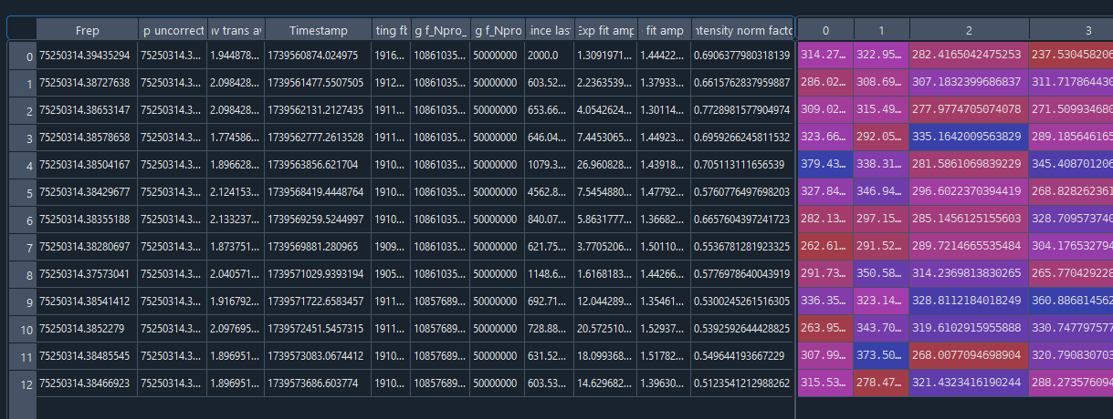
A multi-index provides metadata for each row, which represents one point on the linescan. The counts from the PMT each second are recorded in columns 0-199 (representing the 200 second detection window).
Timestamp provides time at the beginning of the detection window.
Frep is the repetition rate of our frequency comb, which we scan to change the laser frequency. Our fceo is always fixed at -8 MHz. So the absolute frequency of a nuclear transition line is $f=Nf_{rep}+{7f}_{ceo}$
The other columns can be ignored.

Frequency vs time data
Th_record_db.csv = Database of all our data taken since May 2024. For each linescan, there are 6 rows corresponding to the different corrections (raw data, memory correction, memory and intensity correction) and fits tried (Lorentzian, gaussian). The published data for this paper is all Lorentzian fits with ‘mem int’ correction. The one exception is our first set of data with X2 from May 2024, where we use memory corrected Lorentzian (no intensity data available).

Here’s a general guide to the other cols and their meaning:
Name | Options/type | Note
Timestamp | 2020-08-01T00:00:00Z (for python) | Timestamp from beginning of detection window for first point  Note: timezone is GMT time, not MT!
Freq | Freq in Hz
Freq_unc | Freq unc in Hz | With reduced chi2 factored in
FWHM | FWHM in kHz
FWHM_unc | FWHM_unc in kHz | With reduced chi2 factored in
Amp | Peak height
Amp_unc | Peak height unc
Baseline | Fitted baseline
Baseline_unc | Fitted baseline unc
Temp | Temp sensor in K
Chisq_red | Reduced Chi2 of the fit
Correction | Raw, mem, mem int
Peak | a,b,c,d,e
Target | X2, C13, C10 | Which crystal was used
Laser | Menlo lock, Fceo lock | Locking scheme used
Fitting function | Lorentzian, None | Type of fit (none = gaussian fit)
Sweep range | Sweep range in kHz, none | The sweep range in kHz for each point of the linescan.
Linear baseline subtraction | Linear baseline subtraction, none | Baseline count change over the points that was subtracted (none = no subtraction)

